Title
A. B. Author*¹, C. D. Author¹ and E. F. Author²
¹First Affiliation, address
²Second Affiliation, address
*e-mail: Corresponding author’s email address

Background
Introduce the broader context and significance of your research topic. Identify the gap or problem in current knowledge that your work addresses.

Aim and Objectives
State your research aims, hypotheses, or questions.

Methodology
Describe the theoretical framework, methodology, design, data collection methods, or analytical approaches.
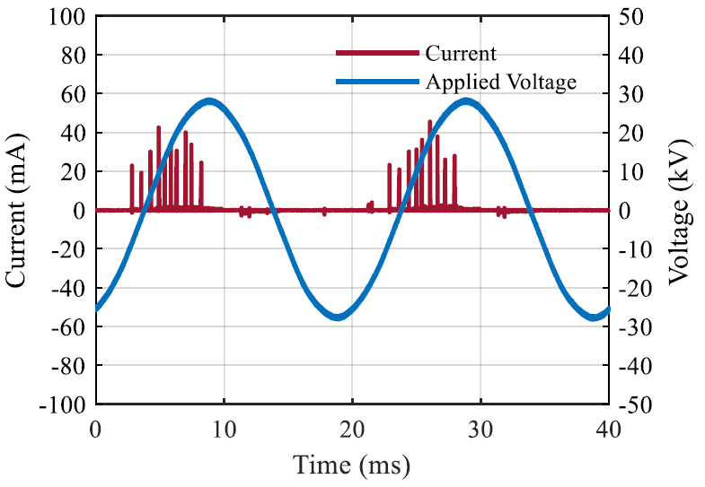
Figure 1. Example figure.

Results
Present your key findings and significant outcomes. Include specific data or evidence where relevant.

Conclusions
Discuss the implications of your findings, their significance to the field, and potential applications or future directions.

References
- A. B. Author et al., "Example article title 1," Example journal title, Vol. 1, Issue 1, pp. 001-002, Month YYYY.
- C. D. Author and E. F. Author, "Example article title 2," Example journal title, Vol. 1, Issue 1, pp. 001-002, Month YYYY.

